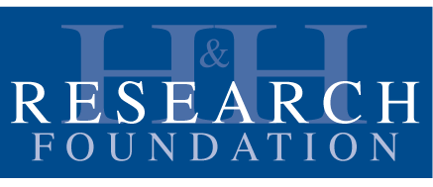

HHRF EQUINE WELL-BEING
GUIDELINES FOR HUMANS FROM THE HORSE'S PERSPECTIVE

This is not a comprehensive list of equine management best practices but is a list from the horse’s perspective of what they need to be involved in research on horse/human interactions. See attached resource list for more information relating to other aspects of equine management outside the scope of this document.

These guidelines were developed by the HHRF Equine Well-Being Task Force and are based on the beliefs that:

- The integrity of the research is directly related to the well-being and suitability of the horses providing the interactions.
- Horses are sentient beings that are aware of, sensitive to, and affected by their environment including the physical and emotional state of others in their presence.
- When a horse is well managed and cared for with consideration and empathy, they build resilience to more effectively and safely cope with the inevitable stresses of life.
- The horse needs to be in optimal physical, mental, and emotional health to enhance their ability to engage with humans.

HHRF wants to go beyond “Do No Harm” to maximizing well-being for “The Highest Good” of the horses, while respecting international cultures and guidelines. We believe this is essential to the quality of the research.

National guidelines or profession-specific competencies for working with horses as part of human services that exist in your country must be followed in the care, welfare, training and handling procedures. Everyone providing equine care, welfare, training and handling should have the appropriate qualifications, training and experience to follow these guidelines. *

*Final paragraph from IAHAIO (International Association of Human Animal Interaction Organizations) “International Guidelines on Care, Training and Welfare Requirements for Equines in Equine Assisted Services”
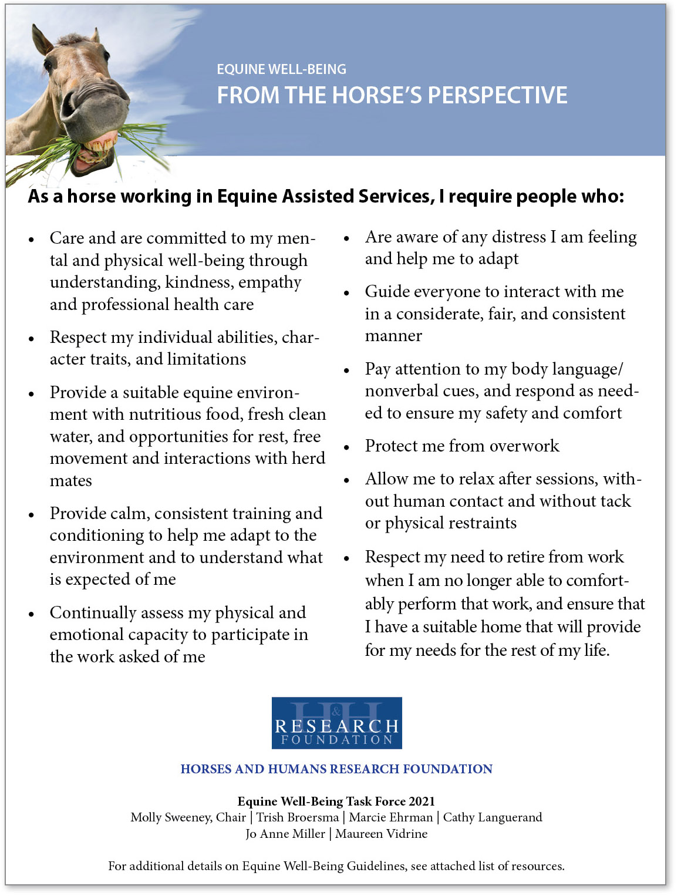

HHRF EQUINE WELL-BEING
RESOURCES

The Cambridge Declaration on Animal Consciousness, 2012: “The absence of a neocortex does not appear to preclude an organism from experiencing affective states. Convergent evidence indicates that non-human animals have the neuroanatomical, neurochemical, and neurophysiological substrates of conscious states along with the capacity to exhibit intentional behaviors. Consequently, the weight of evidence indicates that humans are not unique in possessing the neurological substrates that generate consciousness. Non-human animals, including all mammals and birds, and many other creatures, including octopuses, also possess these neurological substrates.” https://fcmconference.org

The 2020 Five Domains Model: The 2020 Five Domains Model: Including Human-Animal Interactions in Assessment of Animal Welfare by David J. Mellor, Ngaio J. Beausoleil, Katherine E. Littlewood, Andrew N. McLean, Paul D. McGreevy, Bidda Jones and Cristina Wilkins. Published in the peer reviewed Open Access Journal Animals (Basel) 2020 Oct; 10(10):

https://www.ncbi.nlm.nih.gov › articles › PMC7602120

5 Freedoms - They include: freedom from hunger and thirst; freedom from discomfort; freedom from pain, injury, and disease; freedom to express normal and natural behavior; and freedom from fear and distress. "Five Freedoms". Farm Animal Welfare Council / Farm Animal Welfare Committee.

AAEP (American Assoc. of Equine Practitioners) Principles of Equine Welfare www.aaep.org

AHC (American Horse Council) National Welfare Code of Practice www.horsecouncil.org

GFAS (Global Federation of Animal Sanctuaries) Standards for Equine Rescues and Sanctuaries www.sanctuaryfederation.org

HETI (Horses in Education and Therapy International) Ethical Guidelines www.hetifederation.org

IAHAIO (International Association of Human Animal Interaction Organizations) International Guidelines on Care, Training and Welfare Requirements for Equines in Equine Assisted Services www.iahaio.org

ISES (International Society of Equestrian Science) The TEN Principles of Training in Equitation Science https://equitationscience.com/learning-theory

NFACC (National Farm Animal Care Council Canada) Code of Practice-Equines
www.nfacc.ca/codes-of-practice/equine-code

PATH International, Code of Ethics and Standards Manual on Equine Welfare and Management Standards www.PATHIntl.org

Rutgers Equine Science Center https://esc.rutgers.edu

